

Project Manual

Computer Graphics I

Aanchal Sharma

aanchal_sharma@student.uml.edu

**Abstract**  
  
This project aims to create a 3D object by drawing three 2D "elevations". The project implements many features like: modeling, transform object by applying 3D (Translate/Rotate/Scale/SHear) transformations to the created object, viewing the created object from multiple views and generating different projections of the objects.

**Introduction**

The project will employ the use of WebGL which is a JavaScript API for rendering interactive 2D and 3D graphics within any compatible web browser without the use of plug-ins. WebGL is integrated completely into all the web standards of the browser, allowing GPU-accelerated usage of physics and image processing and effects as part of the web page canvas. WebGL elements can be mixed with other HTML elements and composited with other parts of the page or page background. Due to this reason I am choosing to work with it. The project will be able to render user defined images in 3D and also provide the ability to

Transform the object

V_i_e_w_ _t_h_e_ _o_b_j_e_c_t_ _f_r_o_m_ _m_u_l_t_i_p_l_e_ _v_i_e_w_s

Transform the lighting of the object

Generate different projection of the object

Change the perspective projection vanishing points

Create texture/bump/environmental mappings of the object

**Analysis and Design**

**Week 1**: Please refer: <http://www.cs.uml.edu/~asharma/427546s2018/finalProject/finalProject_v1/finalProject.html>

I created the full working model of front and side view of my dream house.

**Week 2:**Please refer: <http://www.cs.uml.edu/~asharma/427546s2018/finalProject/finalProject_v2/2dTransformations.html>. I created the full working model of top view of my dream house. Select R to rotate the view; S for scaling, T for translation; SX for Skewing X-axis; SY for Y-axis Skew and Reset to enter the state representing the natural state.  
I also added a html page to display various planar geometric projections for a cube which we studied in class. In order to view, please refer: <http://www.cs.uml.edu/~asharma/427546s2018/finalProject/finalProject_v2/projections.html>

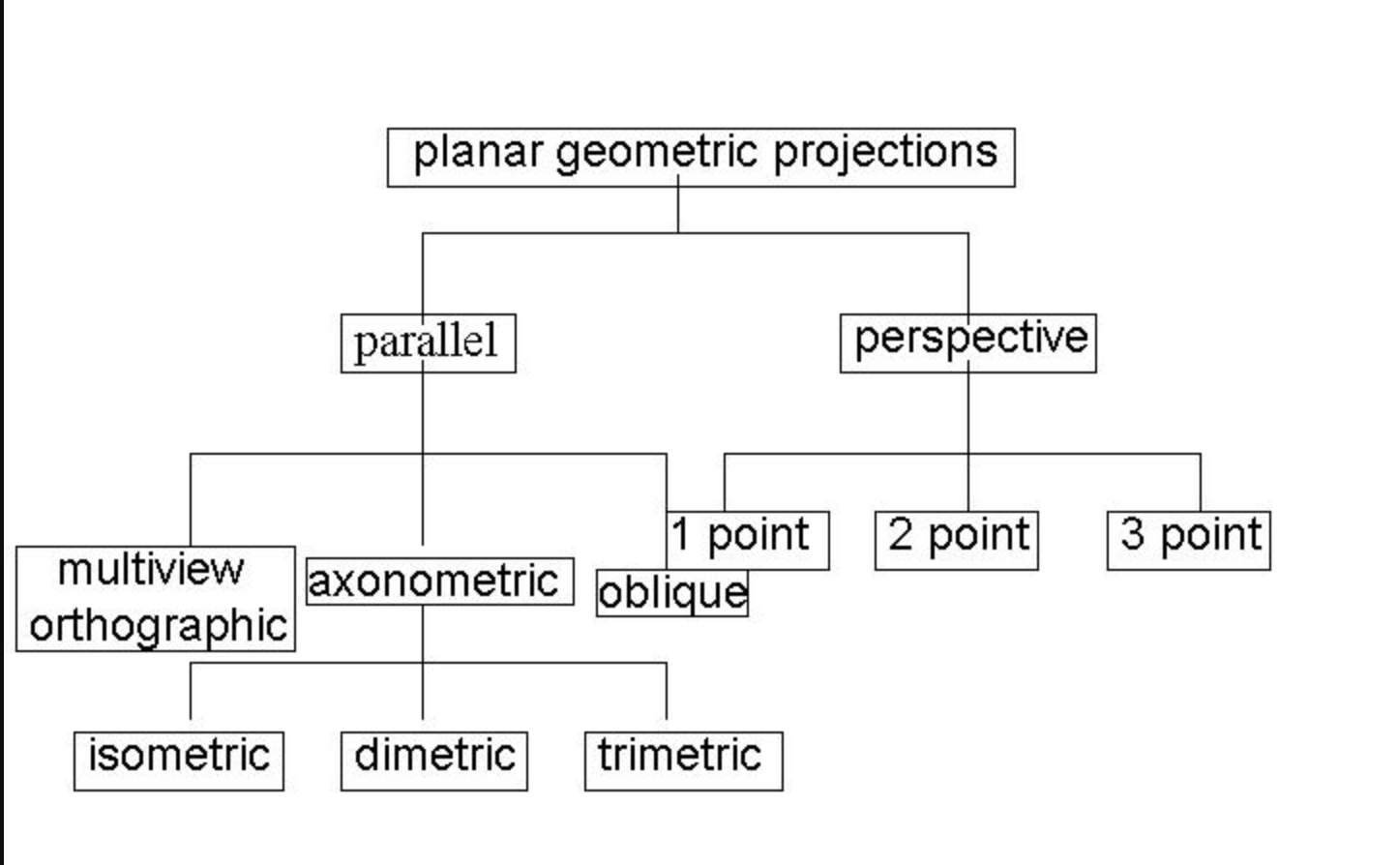

I added the top view of my dream house and the various projections of a cube. 2dTransformations.html deals with all the 2 Dimensional Transformations of dream house and Projections.html has the various Geometric Projections of cube.

**Week 3:**  
1) I created a 3D Transformation of a cube. For that please refer 3dCube.html file

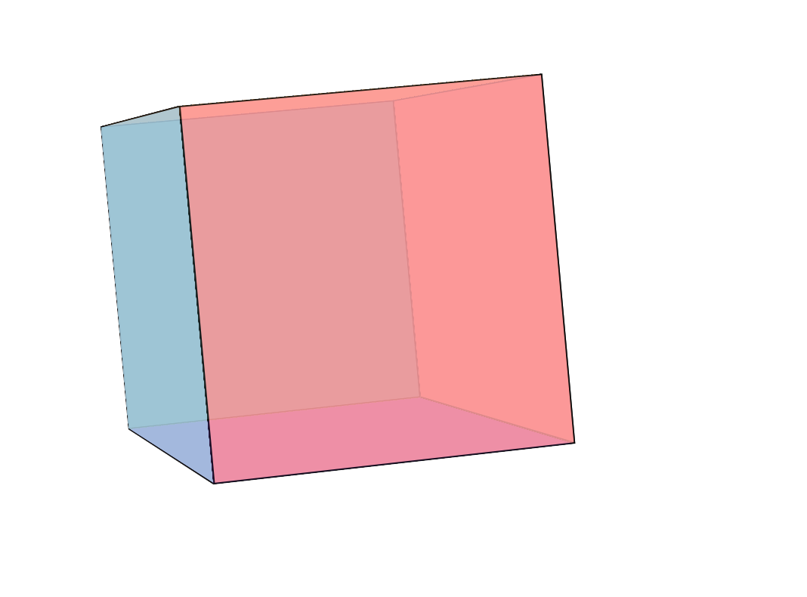 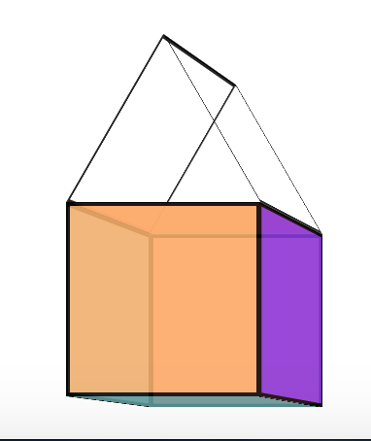

3dCube.html 3DMouse.html

2) I created a 3D Transformation of an object. The transformation changes with the mouse pointer. To view please open the 3DMouse.html file

3) Created a floating object for a hut. To view please refer 3DFloatingHouse.html file

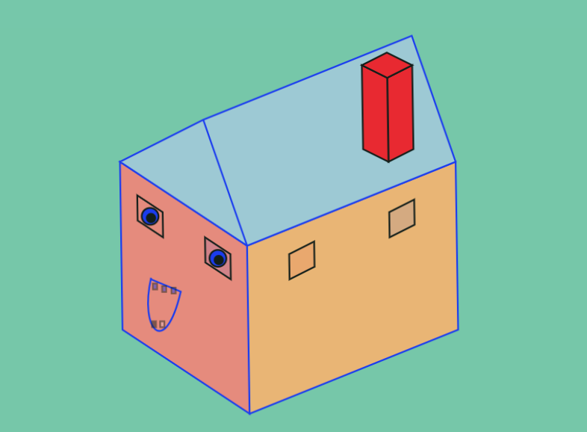

3DFloatingHouse.html

4) Implemented 3D View of a room. The view changes with the movement of mouse. To view please refer room.html file.  
  
The initial view looks something like:

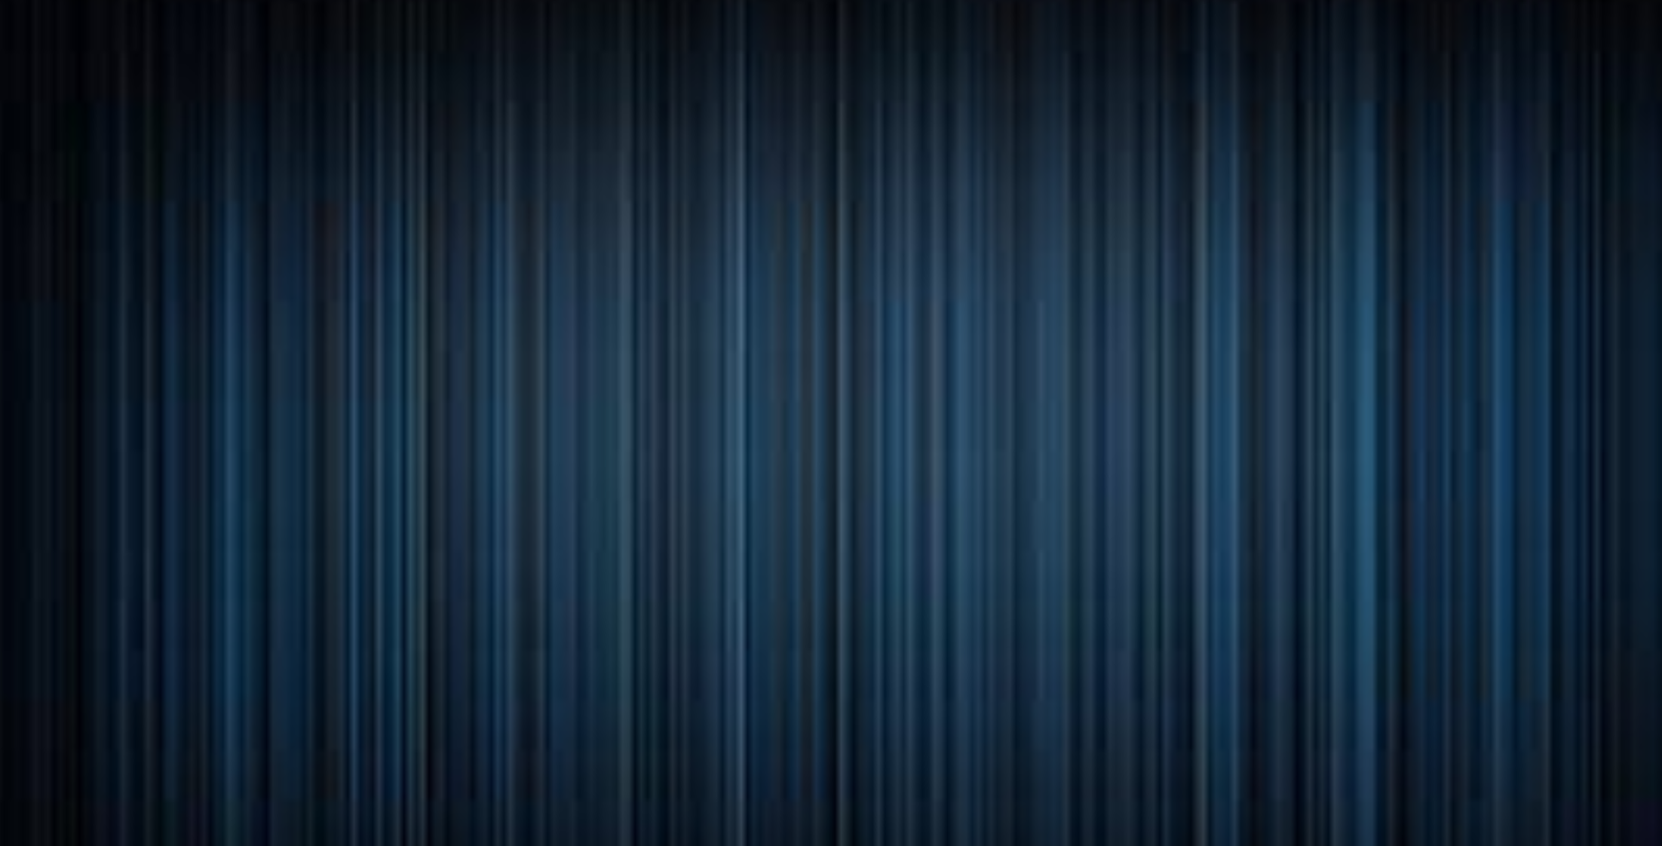

room.html

This is nothing but a room’s wall.   
Click anywhere on the wall/screen and you will be redirected inside the room.

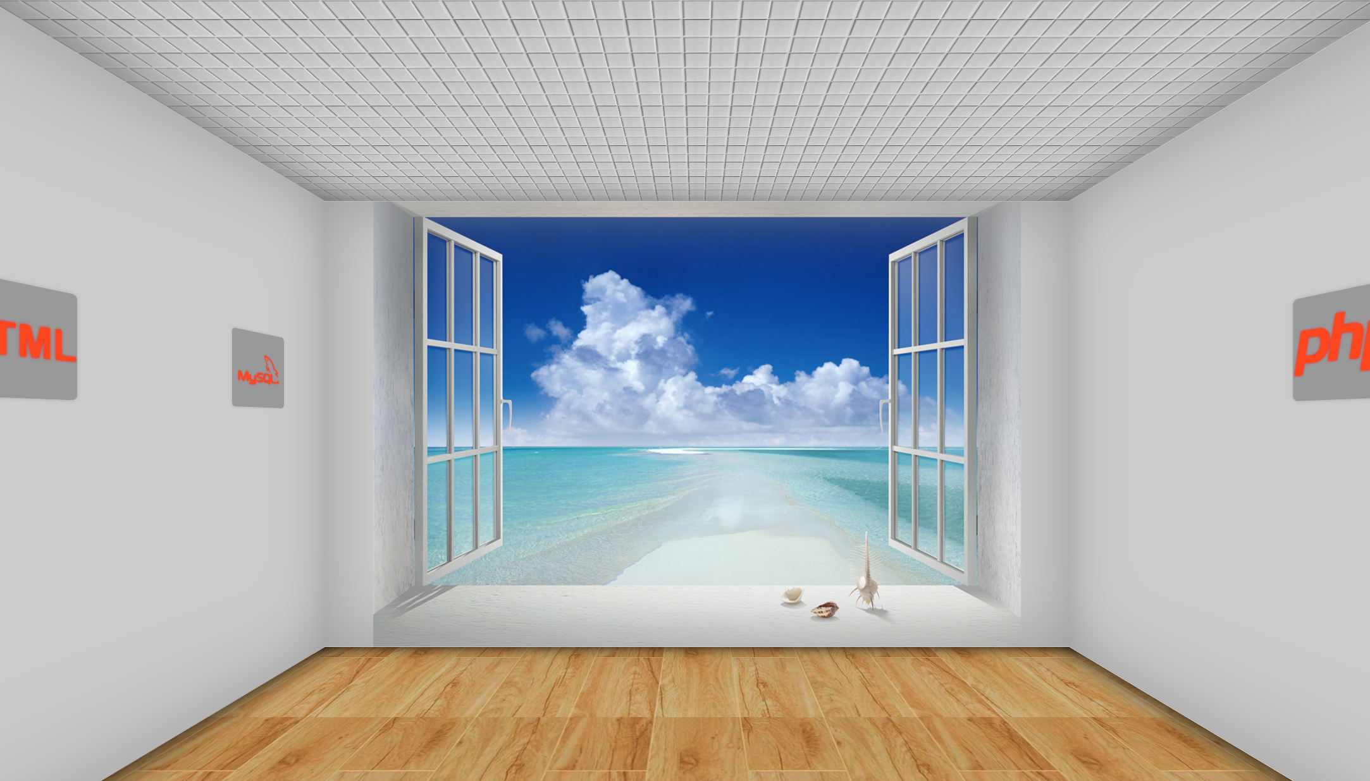

The inside view of the room

**Week 4:**

Page1: Periodic Table

The Tags used in creation of this webpage are: HTML5, javascript, canvas, three.js, animation, colors. The script files used here are: three.js, tween.min.js, TrackballControls.js and CSS3DRenderer.js Check out the online demo at <http://www.cs.uml.edu/~asharma/427546s2018/finalProject/finalProject_v4/periodicTable.html>.

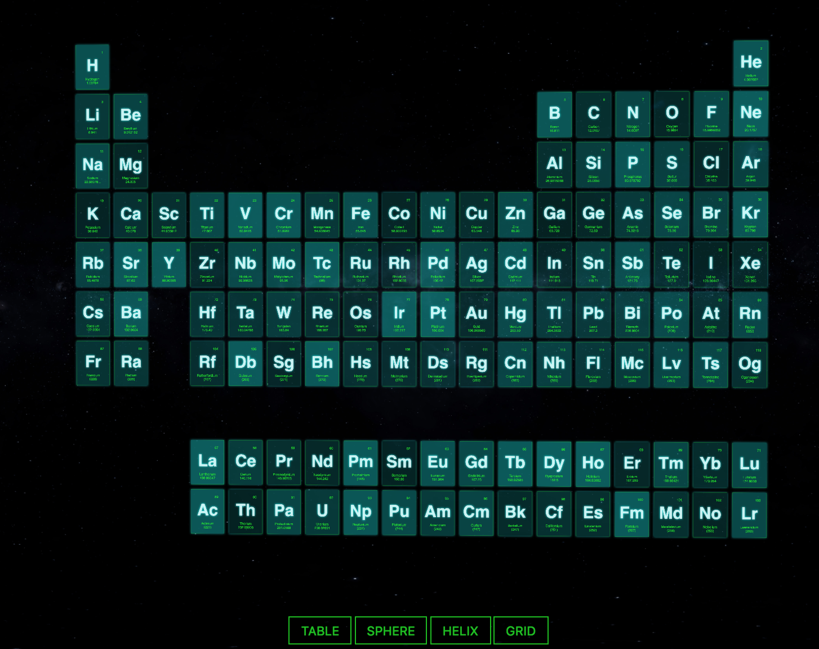

Table View

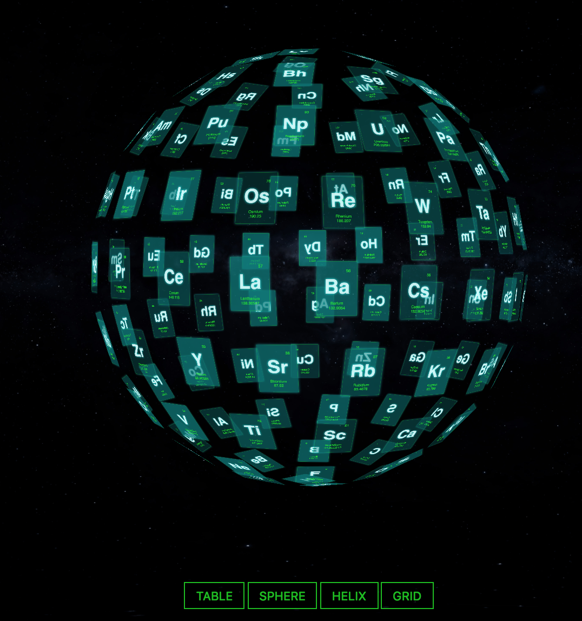

Sphere View

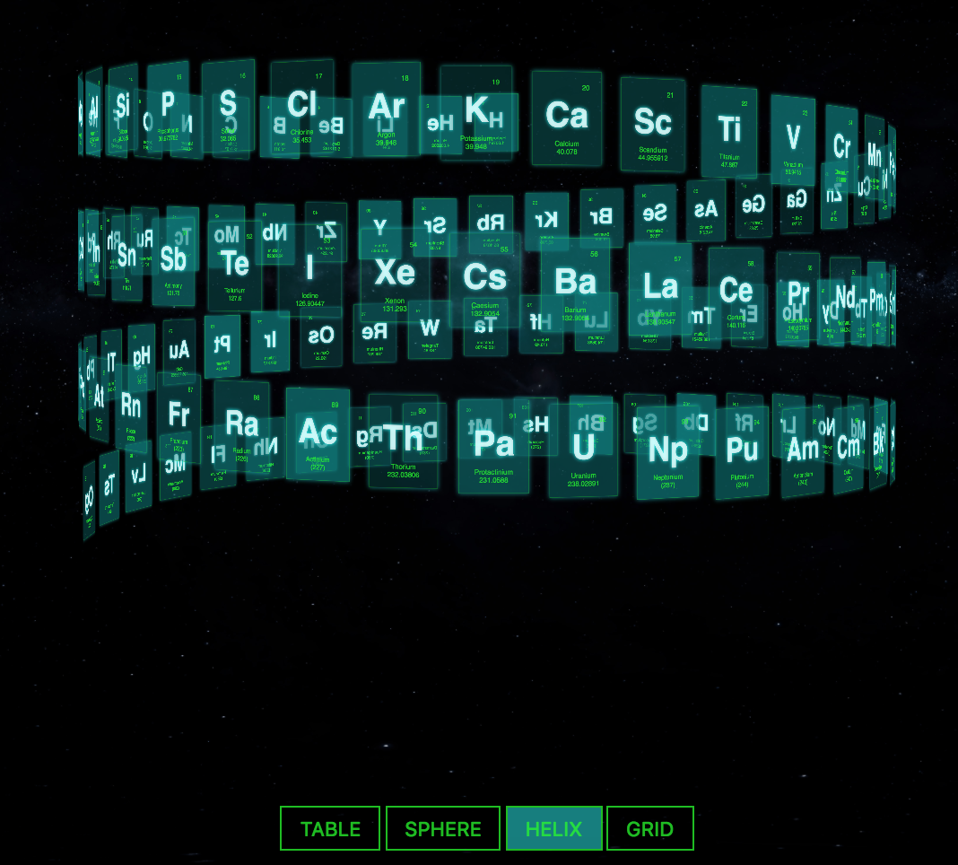

Helix View

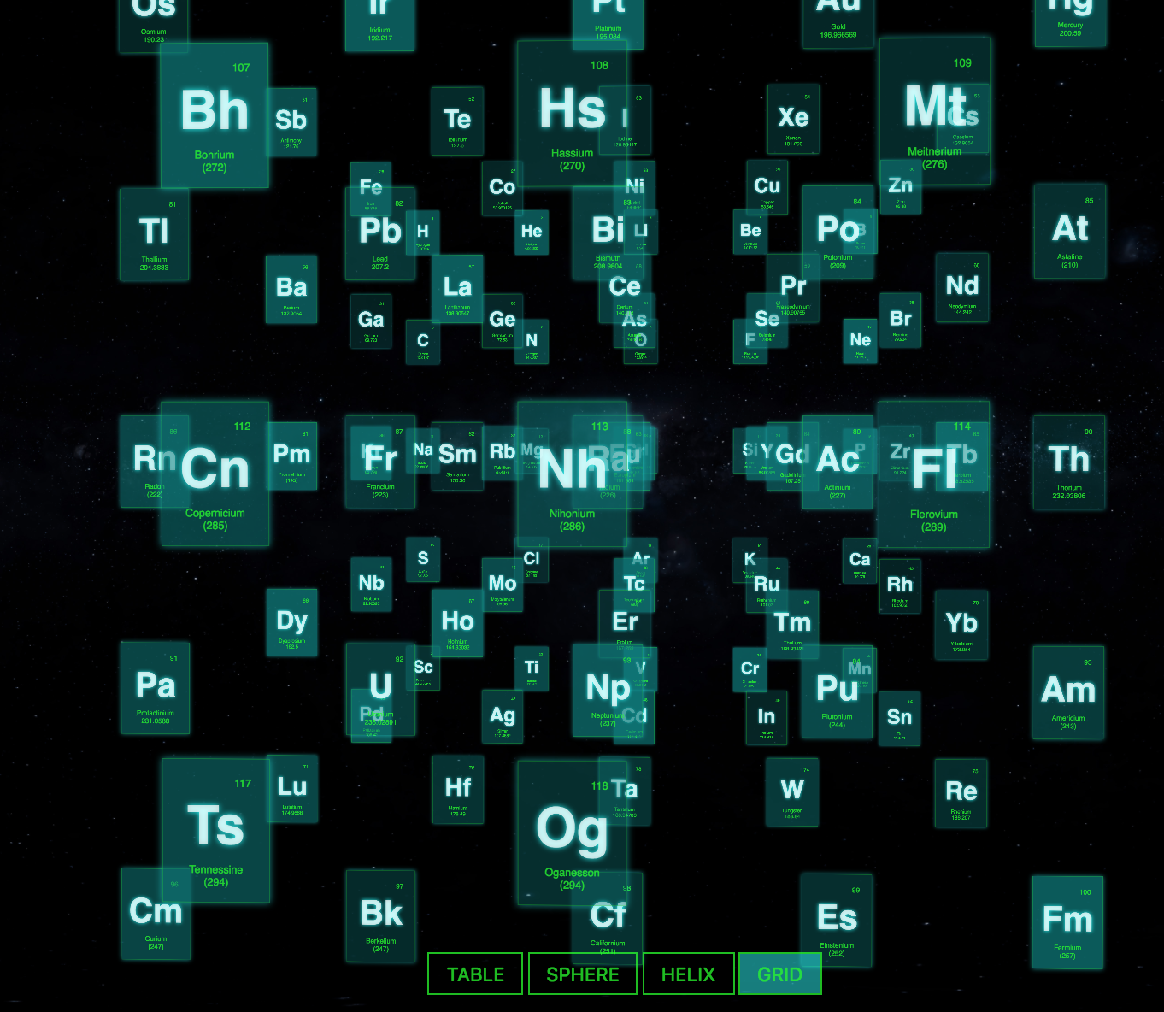

Grid View

Page 2: 3D Animation Lines for animated background color

The Tags used in creation of this webpage are: HTML5, javascript, canvas, three.js, animation, colors. I’m using three.min.js as main JavaScript Library. For Visualization, 3d-lines-animation.js file is used. And then for frequent animated background color, color.js file is used. The Background color keeps changing and 3D Lines can be explored by dragging the mouse onto them. Check out the online demo at <http://www.cs.uml.edu/~asharma/427546s2018/finalProject/finalProject_v4/3DAnimationLines.html>. The script is fully configurable (colors, lines, opacities, perspectives).

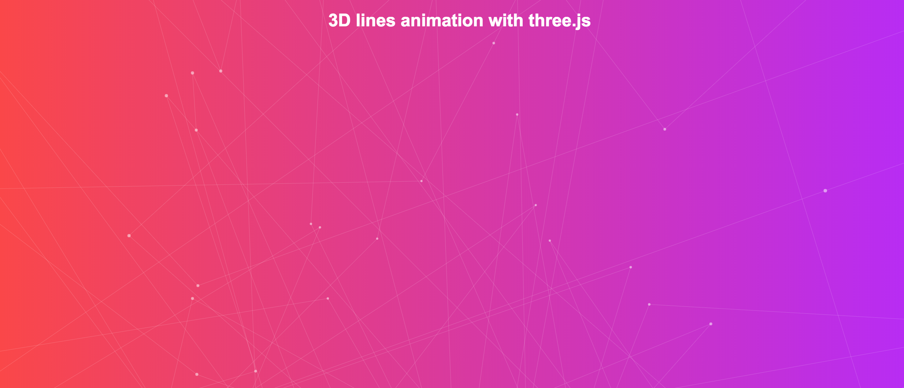

3DAnimationLines.html

Page 3: Basic Camera Movement using three.js and WebGL

The JS file used for for the understanding of the Basics of Camera Movement is Detector.js and three.min.js files. The Tags used in creation of this webpage are: HTML5, javascript, canvas, three.js, animation, camera. I gave the drop-down at the top right to switch between tilt, pan, zoom, pedestal, dolly and truck/track.

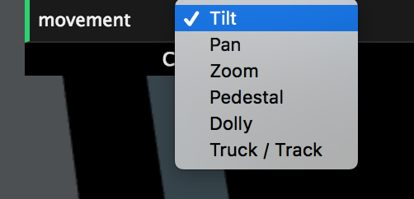

Movement DropDown

For Demo, please click: <http://www.cs.uml.edu/~asharma/427546s2018/finalProject/finalProject_v4/cameraMovement.html>

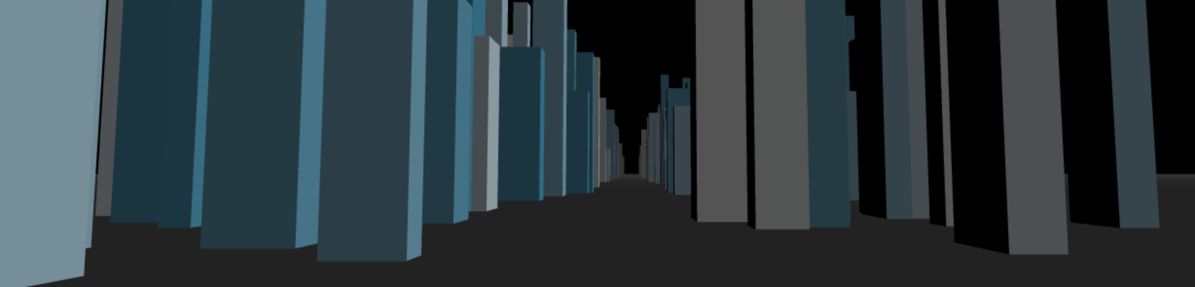

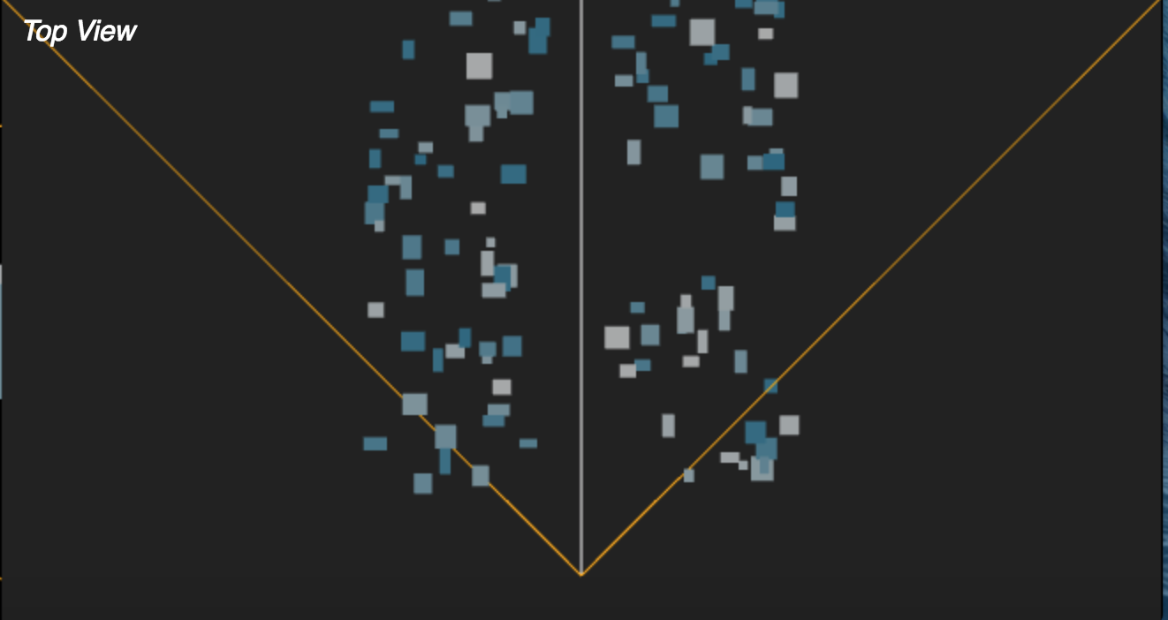

Top View

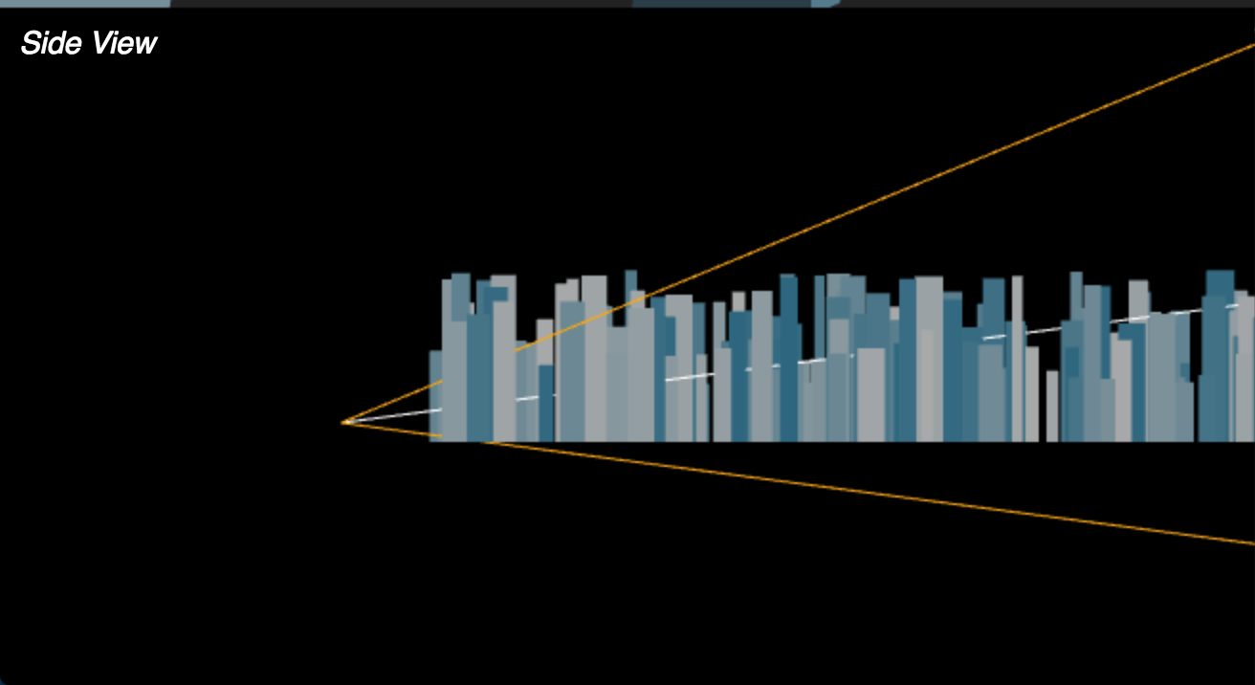

Side View